Name: | ________________________________ |  | Date: ___________
 | Mathematics Methods Unit 1&2  Test 7, 2015  Chapters 6  Topic – Trigonometric Functions |  | 48  = %
Total Time: | 60 minutes
Weighting: | 6% of the year.

This test comprises of TWO sections. The first section is calculator free where no calculators of any kind are to be used. The second section is calculator assumed where the CAS calculator may be used. All questions must be answered in both sections. Answers should be in EXACT form or rounded appropriately. All working should be shown in the space provided. Solutions without working may not be awarded full marks. Please take the marks for each question into account when answering the question.
SECTION 1: CALCULATOR FREE
Time: 45 minutes | Equipment Allowed: SCSA Formula sheets
Marks for Section 1: 37 marks

Circle the correct answer for questions 1 to 5.
1 . [5 marks:1,1,1,1,1]
Find the amplitude and period of the following graph.
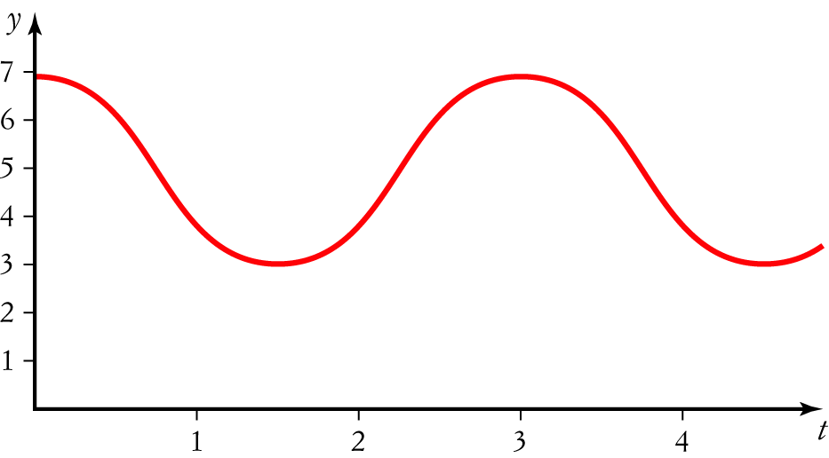
A Amplitude 4, period 4
B Amplitude 4, period 3
C Amplitude 4, period
D Amplitude 2, period 3
E Amplitude 2, period

2 The graph of y = tan (2x) is most like:
A 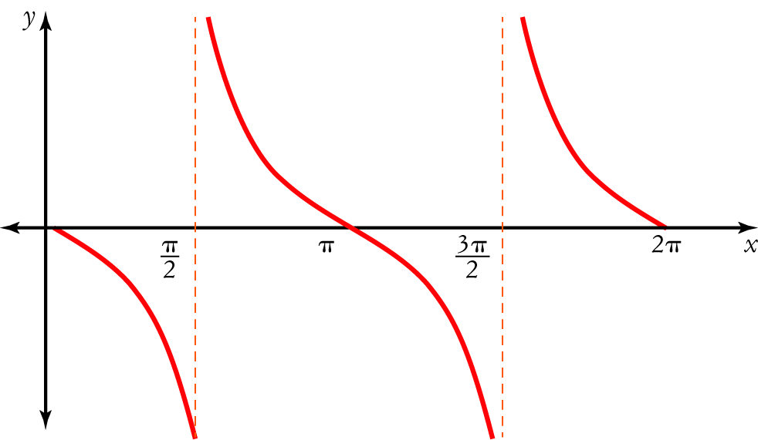
B 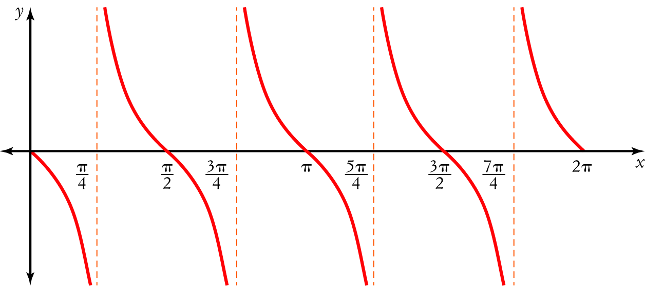
C 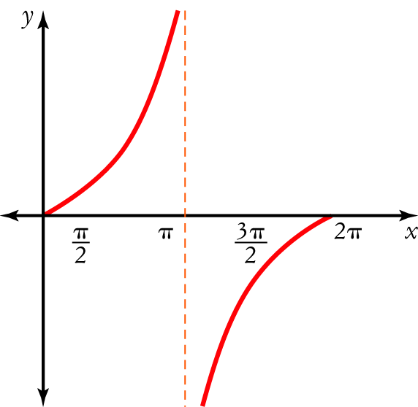
D 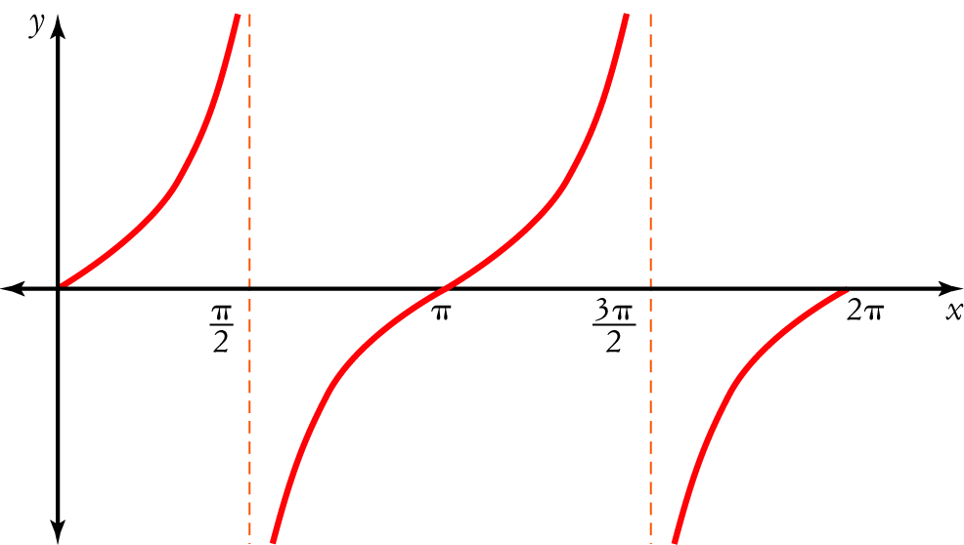
E 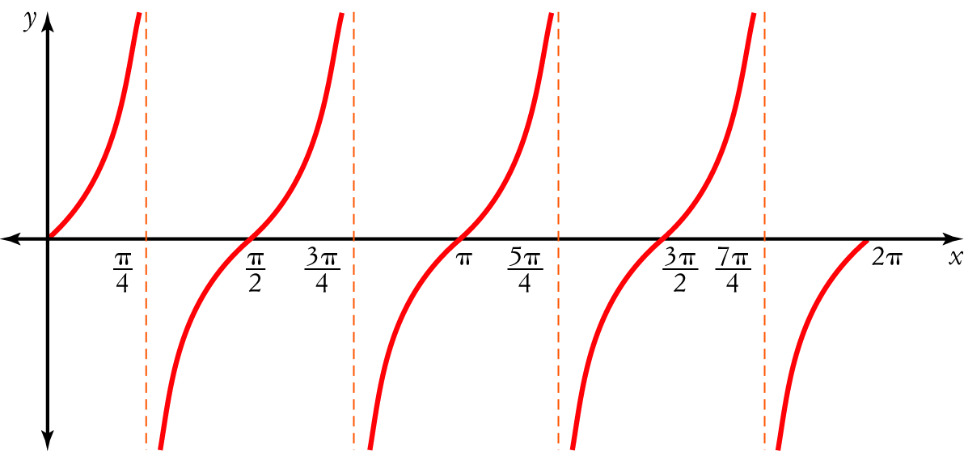

3 Which statement is not correct?
A sin = cos (x)
B cos = sin (x)
C cos = sin (x)
D sin = cos (x)
E cos = sin (x)

4 Which statement is not correct?
A cos (x + y) = cos (x) cos (y) − sin (x) sin (y)
B sin (x + y) = sin (x) cos (y) + cos (x) sin (y)
C tan (x − y) =
D sin (x − y) = sin (y) cos (x) − cos (y) sin (x)
E tan (x + y) =

5 The equation of the function below is:
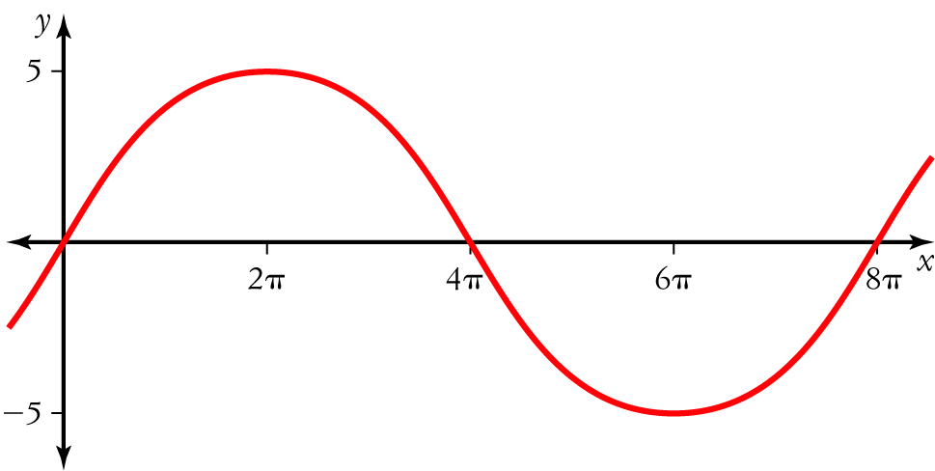
A y = 8 sin (5 x)
B y = 5 sin (8 x)
C y = 5 sin
D y = 5 sin $\left(\frac{x}{4}\right)$
E y = 5 sin (4πx)

6. (5 Marks:1,1,1,1,1)
Find the exact value of
a tan (360°) 0__________________________________________
b sin 1___________________________________________
c cos (180°) -1_________________________________________
d sin (2π) 0________________________________________
e tan (0°) 0_______________________________________

7. (5 marks)
If sin A= and cos B = , find the exact value of cos (A+ B)
Cos (A+ B) = Cos A Cos B – Sin A Sin B
= $\frac{\sqrt{33}}{7}$ x $\frac{3}{5}$ - $\frac{4}{7}x \frac{4}{5}$
= $\frac{3\sqrt{33}}{35}$ - $\frac{16}{35}$
= $\frac{3\sqrt{33}-16}{35}$
8. (10 Marks:2,2,2,2,2) For the domain 0 ≤ x ≤ 2π, sketch the graph of:a y = cos (x)

9. (3 marks) Show that cos (2x) = 1 − 2 sin² (x)
Cos (2x) = Cos (x + x)
= Cos x Cos x – Sin x Sin x
= Cos ² – Sin ² x
= (1- Sin ² x ) - Sin ² x
=1 − 2 sin² (x)

10. (6 marks: 3,3) Solve for 0 ≤ x ≤ 2π
a sin (x) =
x = π/6, 5π/6

b cos (x) = −
x = 2π/3, 4π/3

11. (3 marks)
Solve 2 sin² (θ) − 1 = 0 for 0° ≤ θ ≤ 360°.
x = 45ᵒ, 135ᵒ, 225ᵒ, 315ᵒ

Name: ___________________________________________________ Date: _________________

SECTION 2: CALCULATOR ASSUMED

Time: 15 minutes Equipment Allowed: Formula sheet, 1 page of notes (A4), CAS and scientific calculators

Marks for Section 2: 11marks

12.[6 marks:2,2,1,1] Below is a table showing the average number of daylight hours over several months.
Month | Jan | Feb | Mar | Apr | May | Jun | Jul | Aug
Daylight hours | 15.3 | 14.7 | 13.2 | 13.1 | 12.7 | 12.2 | 12.5 | 13.8

a Draw a graph to display this data.
b Is it periodic? If so, what is the period?
Answer can be periodic ( due to common sense based on the first sentence)
then period is 12 months or 1 year
Answer can be non-periodic ( base on the given data)

c Find the amplitude.
If answer to (b) is periodic then amplitude is 1.55
If answer to (b) is non-periodic then there is no amplitude

d Approximately how many daylight hours would you expect there to be in November?
About 15 hours

13. [5 marks:4,1]
The sales, S, in 100s of units, of a seasonal product are modelled by S = 54.8 + 32.5 cos
where t is the time in months (t = 1 is January and t = 12 is December).
a Sketch a graph of the sales for a period of 12 months.

b Use the graph to find the months when sales were greater than 6800 units.
January, February, October, November and December

